INTERNSHIP OFFER - 1531
Ref : RI-ISL-CVC-H266-1

LAB: | ISl |  | TA: | Core Video Coding | PROJECT: | H266
Surpervisor(s): |  | Fabrice.Leleannec@InterDigital.com

TO REPLACE BY THE INTERNSHIP TITLE  To replace by the internship short description  Skills: to replace by the set of requested skills  Keywords: to replace by a set of keywords | Beyond VVC – towards the Future video codec  VVC is the new video coding standard jointly developed by MPEG and VCEG. VVC is the successor of H.265/HEVC and is going to be issued in 2020. The compression gain is expected to be around 35-45% over HEVC.  Video coding is one of the pilars of InterDigital activities. InterDigital has been involved in video coding standardization, including in the VVC development.  The internship aims at preparing the next video coding generation, beyond VVC. The main goal of the internship will be to study some compression tools explored during the VVC standard development and to port into the VVC software codec in view of improving the coding performance. The aspect of parallel encoding can also be investigated to better control the encoding time. The studied software will be the VVC reference software. The work will include a significant amount of C++ software development.  The internship will take place in a research team of around 15 video coding and standardization experts.  Skills: video coding, signal and video processing, C++ programming, parallel processing  Keywords: video coding, block partitioning, motion prediction, motion coding, HEVC, JVET

INTERNSHIP OFFER - 1532
Ref : RI-ISL-CE-PCC-2

LAB: | ISL |  | TA: | Compression Ecosystem | PROJECT: | PCC
Surpervisor(s): |  | Julien.Ricard@InterDigital.com , Celine.Guede@InterDigital.com

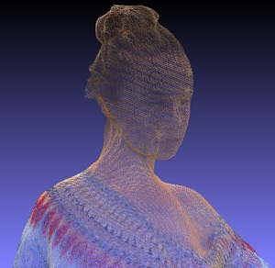  TO REPLACE BY THE INTERNSHIP TITLE  To replace by the internship short description  Skills: to replace by the set of requested skills  Keywords: to replace by a set of keywords  First PCC prototype | Live Point Cloud Compression demo  Point cloud is an image format well-suited to handle material captured with 6 degrees of freedom, natural content and real-time processing. Point cloud applications covers AR/VR/MR video, culture heritage and modelling, maps and autonomous cars.  Typical point clouds count millions of points with a corresponding huge bitrate (in Gbps) so that compression is required for adoption by the industry. Point cloud compression (PCC) may rest upon video coding technologies leveraging high compression efficiency, facilitated deployment and easy upgrade to new standards. InterDigital is a major contributor to MPEG into which PCC is standardized as MPEG-I part 5 and 9. PCC standards are planned to be completed early 2020.  In order to promote MPEG solution for enabling future deployment, a first prototype has been setup demonstrating real-time video point cloud decoding of pre-stored material on commercially available smartphones. The goal of the internship is to extend current prototype by implementing an end-to-end live PCC chain that will be used as a demonstrator in international standardization meetings and trade fairs.  The internship will focus on setting up and improving:  - acquisition and capture stages of the live PCC demo. As it is, you will improve tools to calibrate multiple depth cameras placed at different arbitrary positions to capture shot environment as a point cloud  - real-time encoding and streaming stages of the live PCC demo. You will enhance and optimize an existing encoder based upon HEVC to reach real-time performance and adjust a streaming library to both encoder and decoder  Skills:  - a strong programming background (C, C++)  - facility to program in existing complex projects  - a good knowledge of video coding  - a knowledge of open source video coding projects (Ffmpeg, x265...) is a plus  You will enforce a team of video coding and image processing experts and considered as a full team member with appropriate support.  Keywords:  video coding, point cloud compression, C++

INTERNSHIP OFFER - 1565
Ref : RI-ISL-CE-PCC-8

LAB: | ISL |  | TA: | Compression Ecosystem | PROJECT: | PCC
Surpervisor(s): |  | Yannick.Olivier@InterDigital.com , Pierre.Andrivon@InterDigital.com

TO REPLACE BY THE INTERNSHIP TITLE  To replace by the internship short description  Skills: to replace by the set of requested skills  Keywords: to replace by a set of keywords | Point Cloud Compression future developments  Point cloud is an image format well-suited to handle material captured with 6 degrees of freedom, natural content and real-time processing. Point cloud applications covers AR/VR/MR video, culture heritage and modelling, maps and autonomous cars.  Typical point clouds count millions of points with a corresponding huge bitrate (in Gbps) so that compression is required for adoption by the industry. Point cloud compression (PCC) may rest upon video coding technologies leveraging high compression efficiency, facilitated deployment and easy upgrade to new standards. InterDigital is a major contributor to MPEG into which PCC is standardized as MPEG-I part 5 and 9. PCC standards are planned to be completed early 2020.  The internship will focus on studying future developments of Point Cloud Compression. Possible tracks comprise tools extension or improvment of upcoming PCC standards and deep learning applied to PCC.  You will enforce a team of video coding and image processing experts and considered as a full team member with appropriate support  Skills:  - a strong scientific background in image processing and video coding domains  - facility to read, implement, propose enhancements to state of the art methods and scientific papers  - a good knowledge of C++, Python and numerical computing programming languages  - a good knowledge of machine learning or deep learning applied to video processing  - a knowledge of video coding standards (e.g. HEVC, VVC, PCC) is a plus  Keywords: point cloud compression, video coding, video processing, video algorithms, machine learning, deep learning, AI
INTERNSHIP OFFER - 1573
Ref : RI-ISL-CE-DTV-9

LAB: | ISL |  | TA: | Content Processing | PROJECT: | Digital TV
Surpervisor(s): |  | Hassane.Guermoud@InterDigital.com

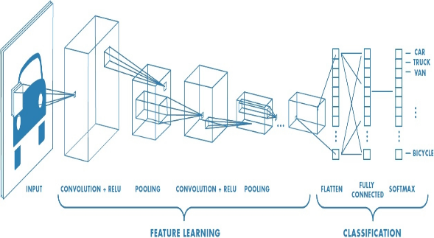 | Gesture Recognition Based on Unsupervised Deep Learning Framework  Touchless device control is a way of Natural User Interface to interact with objects in many application domains like automotive, smart TV, smart mirror, games etc…  Gesture recognition can be considered as a milestone technology to have a natural interaction with our environment.  The goal of this internship is to explore and propose a new framework based on unsupervised neural network to achieve a gesture recognition for digital TV application where hands features are extracted and tracked as well in the spatial and temporal domain.  Skills:  - Python/C++ programming, ideally with image processing expertise and machine learning (deep learning, auto-encoders, GAN)  - Ability to write well-structure and documented code  - Good written and spoken English  - Excellent team working skills as the internship forms a part of a larger project, involving many team members  - Ability to work independently  Keywords: Machine Learning, Deep Learning, Tensorflow/ Pytorch backend, MobileNet SSD v2, rendering engine, 3D model.

INTERNSHIP OFFER – 1574
Ref : RI-ISL-CE-DTV-10

LAB: | ISL |  | TA: | Content Processing | PROJECT: | Digital TV
Surpervisor(s): |  | Thomas.Morin@InterDigital.com

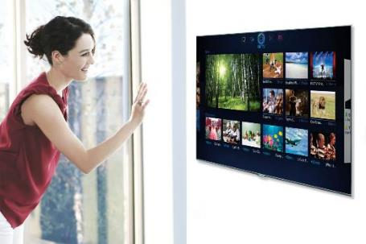 | Digital TV 3D Gesture GUI  Touchless device control is a way of Natural User Interface to interact with objects in many application domains like automotive, smart TV, smart mirror, games etc…  The project team works on improving the quality of gesture detection and thinking new gestures that can control a TV Graphical User Interface.  The goal of this internship is to think, propose and assess innovative 3D Graphical User Interfaces fitting new types of gesture controls.  Skills:  - 3D programming – with a preference for web-browser technologies (WebGL or Three.JS…or Unity).  - Graphical Design skills  - Creativity  - Ability to write well-structure and documented code  - Good written and spoken English  - Excellent team working skills as the internship forms a part of a larger project, involving many team members  - Ability to work independently  Keywords: GUI, 3D, Interface, Gesture, Control, WebGL, Three.JS, Unity, Graphical Design, Software, Programming, Creativity, Digital TV

INTERNSHIP OFFER - 1575
Ref : RI-ISL-CVC-Deep-11

LAB: | ISL | TA: |  | Video Compression | PROJECT: | Deep Compression
Surpervisor(s): |  |  | Franck.Galpin@InterDigital.com , Philippe.Bordes@InterDigital.com

TO REPLACE BY THE INTERNSHIP TITLE  To replace by the internship short description  Skills: to replace by the set of requested skills  Keywords: to replace by a set of keywords | DEEP-LEARNING BASED NEXT GENERATION VIDEO CODEC SPEED-UP  The topic of this internship is the development of Deep Learning based methods to speed-up/improve state-of –the-art video codec (namely VCC/H.266). The goal of the internship is to tackle the combinatory problem arising with new generation codecs, especially because of the enhanced block topologies available in the codec. The goal is to manage combinatory reduction without decreasing the codec performance.  Deep Learning based methods have already proved their efficiency for intra coding mode  (see http://phenix.int-evry.fr/jvet/doc_end_user/documents/10_San%20Diego/wg11/JVET-J0034-v2.zip).  Many extensions are possible, especially regarding the inter coding mode, dealing with motion field segmentation. The candidate should be familiar with current machine learning software packages and have a good background in image processing in general.  Skills: (deep) learning algorithms and software, programming (C++/python), motion estimation  Keywords: video codec, machine learning, motion segmentation, image processing

INTERNSHIP OFFER - 1576
Ref : RI-ISL-CVC-Deep-12

LAB: | ISL | TA: |  | Video Compression | PROJECT: | Deep Compression
Surpervisor(s): |  |  | Franck.Galpin@InterDigital.com , Philippe.Bordes@InterDigital.com

TO REPLACE BY THE INTERNSHIP TITLE  To replace by the internship short description  Skills: to replace by the set of requested skills  Keywords: to replace by a set of keywords | DEEP-LEARNING BASED VIDEO COMPRESSION  The topic of this internship is the development of Deep Learning based methods applied to video coding. The goal of the internship is to leverage the Neural Networks capabilities to improve traditional video coding tools such as post-filters, entropy coding or picture partitioning.  The candidate should be familiar with current machine learning software packages and have a good background in image processing in general.  Skills: (deep) learning algorithms and software, programming (C++/python)  Keywords: video codec, machine learning, image processing

